**LAB ASSIGNMENT #1**

**(a)**

**STATEMENT:** WRITE A PROGRAM TO STORE AND DISPLAY RECORDS OF 20 STUDENTS.

**ALGORITHM:**

Step 1: Start.

Step 2: Declare integer i, rn.

Step 3: Declare character fname, lname, faculty and address.

Step 4: Input record of 20 students.

Step 5: Declare i is equals to 0 to i is less than 20.

Step 6: if (i is less than 20)

then, go to step 7.

else,

go to step 18.

Step 7: Input the record number.

Step 8: Input Roll No.

Step 9: Input First Name.

Step 10: Input Last Name.

Step 11: Input Faculty

Step 12: Input Address

Step 13: Print Roll No.

Step 14: Print First Name.

Step 15: Print Last Name.

Step 16: Print Faculty

Step 17: Print Address

Step 18: Stop

**SOURCE CODE:**

#include<stdio.h>

#include<conio.h>

void main()

{

flushall();

clrscr();

int i;

typedef struct

{

int rn;

char fname[10];

char lname[10];

char faculty[10];

char address[10];

}record;

record student[20];

printf("\n Input record of 20 students \n");

for(i=0;i<20;i++)

{

printf("\n Input student record: %d",i+1);

printf("\n Roll No.:");

scanf("%d",&student[i].rn);

printf("\n First Name:");

scanf("%s",student[i].fname);

printf("\n Last Name:");

scanf("%s",student[i].lname);

printf("\n Faculty:");

scanf("%s",student[i].faculty);

printf("\n Address:");

scanf("%s",student[i].address);

}

for(i=0;i<20;i++)

{

printf("\n Roll No.: %d",student[i].rn);

printf("\n First Name: %s",student[i].fname);

printf("\n Last Name: %s",student[i].lname);

printf("\n Faculty: %s",student[i].faculty);

printf("\n Address: %s",student[i].address);

printf("\n");

printf("\n ********************");

}

getch();

}

**OUTPUT:**

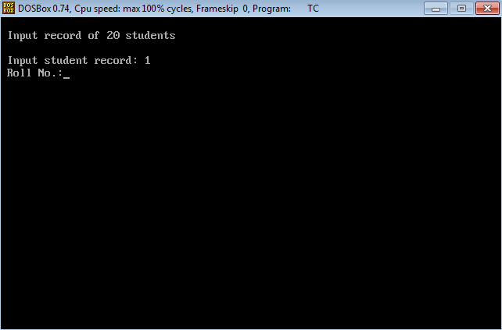

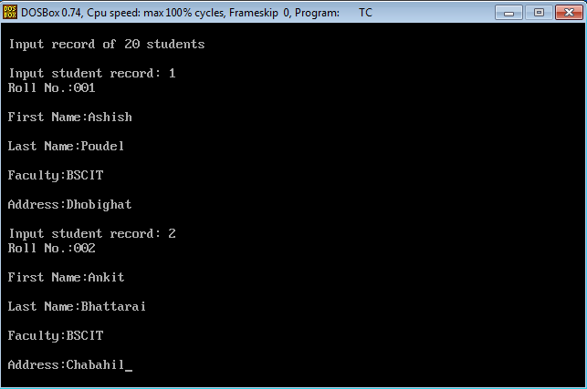

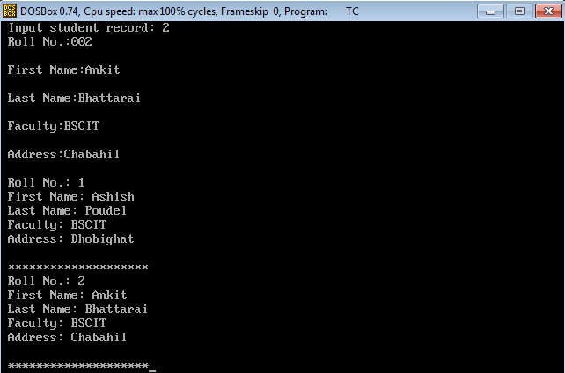

**CONCLUSION:** Hence, the program was successful, and the records of 20 students were stored and displayed.

**(b)**

**STATEMENT:** WRITE A PROGRAM TO FIND THE LARGEST AND SMALLEST NUMBER IN GIVEN LISTS OF NUMBER USING ARRAY.

**ALGORITHM:**

Step 1: Start

Step 2: Declare integer x[5], i, k and temp.

Step 3: Input 5 integer numbers.

Step 4: Declare i is equals to 0 to i is less than or equals to 4.

Step 5: Scan x[i]

Step 6: Declare i is equals to 0 to i is less than or equals to 3.

Step 7: Declare k is equals to i to k is less than or equals to 4.

Step 8: if (x[k] is greater than x[i])

then, goto step 9.

else,

goto step 12.

Step 9: temp is equals to x[i]

x[i] is equals to x[k]

x[k] is equals to temp.

Step 10: Print the largest number.

Step 11: Print the smallest number.

Step 12: Stop

**SOURCE CODE:**

#include<stdio.h>

#include<conio.h>

void main()

{

clrscr();

int x[5],i,k,temp;

printf("\n Input 5 integer nos. = ");

for(i=0;i<=4;i++)

scanf("%d",&x[i]);

for(i=0;i<=3;i++)

{

for(k=i;k<=4;k++)

{

if(x[k]>x[i])

{

temp=x[i];

x[i]=x[k];

x[k]=temp;

}

}

}

printf("\n %d is largest no.",x[0]);

printf("\n %d is smallest no.",x[4]);

getch();

}

**OUTPUT:**

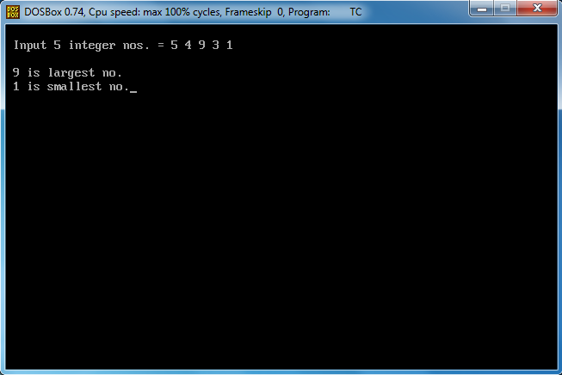

**CONCLUSION:** Hence, the program was successful and the largest and smallest numbers in the given lists of number were found, using array.